Slovenská Technická Unvierzita v Bratislave Fakulta Informatiky a Informačných Technológií
Data Structures and Algorithms
Assignment 2. – Search in dynamic sets

by Olivér Izsák
AIS ID: 112294
Academic year: 2020/2021
2.April 2021

Contents:
1. Hashing table implementation
2.Binary search tree testing.
3.Hash table testing.

1.Hash table implementation.
Hash table is a data structure that can map keys to values. It uses hash function to create a hash code into an array. One problem that arises when using this data structure is the so called “collision”. Which happens when for 2 different values the same key is created.
There are 2 main methods that can be used to solve this problem. One is called open hashing(separate chaining), the other is closed hashing(open addressing).
In my implementation I used closed hashing to resolve collisions.
Hash table Space complexity: O(n) is linear in both worst and best case.
Hash table Time complexity is O(1) constant in best case, and O(n) linear in worst case.
My method of implementation was very simple. It consists of 5 important methods:
initialize();
searchHT();
insertHT();
createKey();
sizeIncrease();
I used 2 global variables. Size is the default hash table value that is given by the user before starting the program, this will not change. And another global variable which is not static, changedSize, this changes when we increase the size of the hash table.
1.void initialize()
I use this method to initialize my hash table.
2.int createKey(int data)
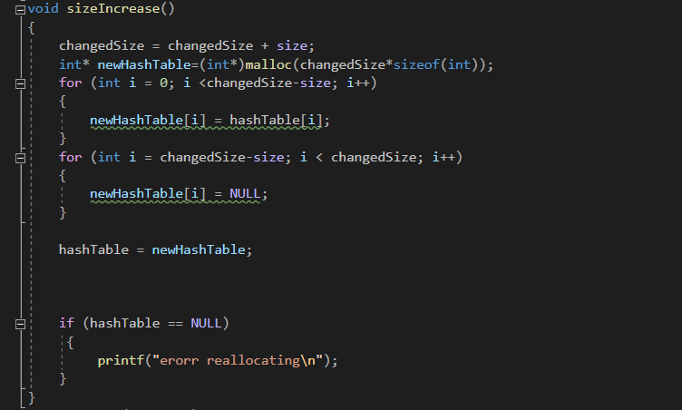
This method creates the specific key for storing the data in the table.
I’m using a simple hashing function where I take the modulo of the given data, meaning the
data is always an int, I created it this way so I can easily compare it to the other implementations I found on the internet. Since they all use integers for the data.
3.void sizeIncrease()
This method is called whenever the hash table is full and a new data is added.
It will add the same amount of free slots to the hash table that was given by the “size” global variable. Eg: size’s value is 10. And I want to increase the size of my hash table. It will add another 10 free slots to the array. I will call each added size, a section.
The reason I did this was because if I just increased the size by 1 slot then if it is used more then the hash table basically just becomes a normal array. The way I implemented is if I have my original 10 sized hash table full(0-9), and I for example want to add a new value that has the key 6. Then this value will be added to the array slot 15.(10-19 section). Because of this If Im going to search in the hash table for a value that has the key 6. First It will check the array section from 0-9, first checking the 5th array slot, then going through the whole 0-9 array sections. After that it will check the 15th slot. And then again go through the 10-19 section.
int searchHT(int data)
In the search method I first go through all the most likely places I will find the value with the given key. After that I will go to the next array slot, and the next and so on, until I get to the end of that one particular array section, and start from the beginning until I get to the one I started from. After this I go to the next array section.
Eg.: My starting hash table size is 10. I increase the size 4 times. Meaning now my hash table has the size of 50. If I want to search for a value with the key of 5, then first I will check the
0-9 array section’s 4th place, (Which is the 5th place), after that I go to the next section 10-19, check the 14th place, then 20-29 section. etc… After I checked all the most likely place where they could be, and still not found. Then I will start from first array section again 0-9, but this time not checking the 4th place,but the 5th, 6th …. until 9th, then starting from the
start 0th,1st…3rd. Then doing the same in the next section.
void insertHT(int data)
This method inserts the data into the hash table. First trying to insert it into the array slot with the same index as the hash key. If that’s not possible, then inserting it into the next one etc. If it is not possible to insert because hash table is full then, it will call the sizeIncrease method, that will increase the size of the hash table, which allows the storage of the data to the next array section’s most probable value.
Testing closed hash table
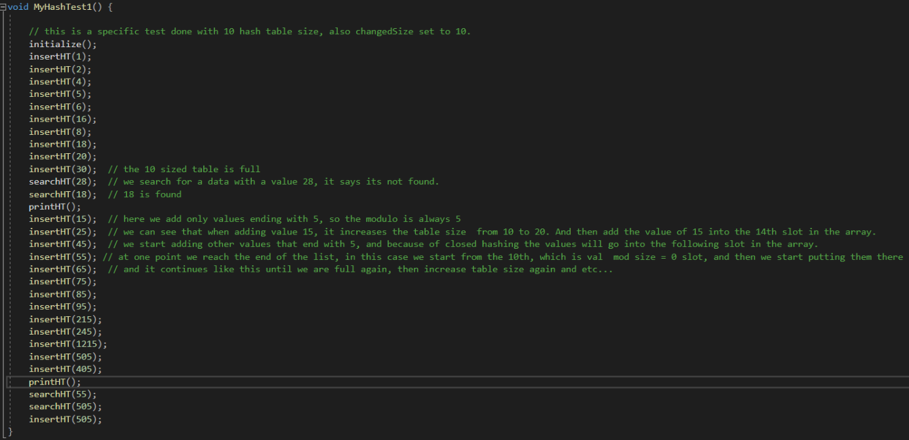
For testing hash tables I created 2 tests:
1.Basic hash table test - testing the insert,se arch functionalities
Result of the test:
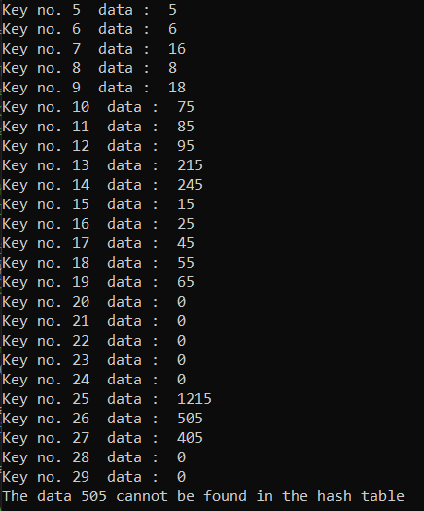

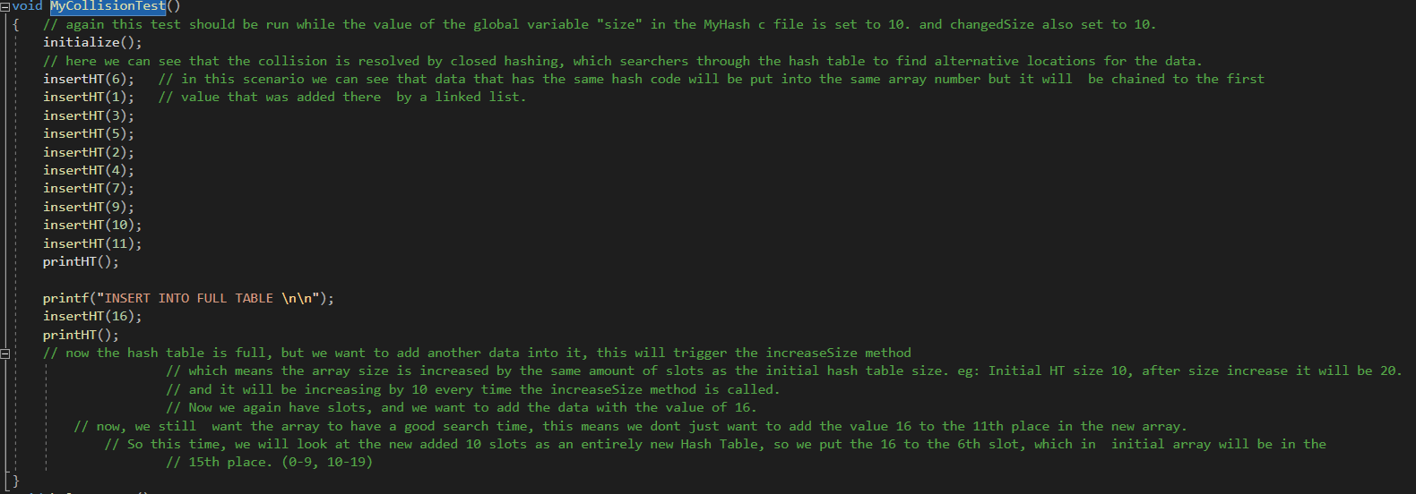
2.Collision test - testing collisions.
Result of the test:
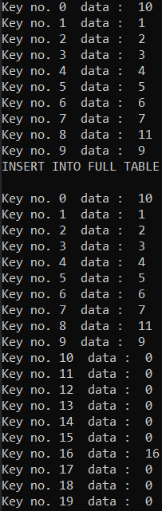
2.Binary search tree
I have taken the the following Red Black Tree implementation from the internet to do the binary search tree tests:
Source: https://gist.github.com/aagontuk/38b4070911391dd2806f

Red Black Tree is a self-balancing three which consists of only black and red nodes. The tree has 4 main properties:
1.The root is always black
2.Every unused leaf (NILL) is black
3.The child of a red node is always black
4.Any simple from a node to its descendant leaf has the same depth.
Red black tree table Space complexity: O(n) is linear in both worst and best case.
Search,delete and insert have logarithmic Time complexity: O(log n)

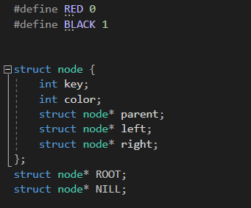
Header file defines the node stucture, which consists of int,key which are both int type and 3 pointers, to right child,left child and parent.

Insert function:
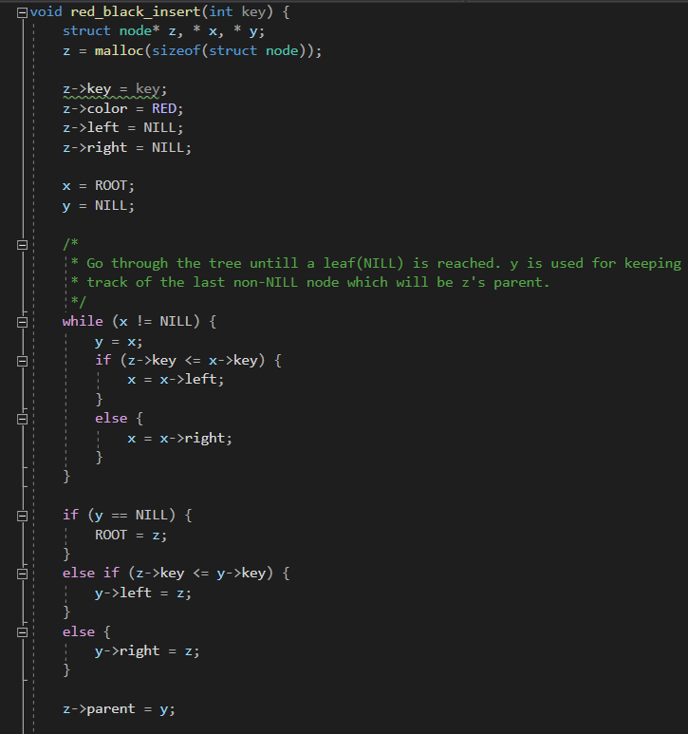
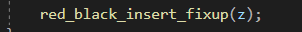
The Insert function creates a new node, the key will contain the inserted data.
It’s colour will be red when inserted and will have 2 NILL leaves.
After that the algoorithm will go through the tree using a while loop, checking the leaves and their values to insert the new node into the tree properly according to its value. After the while loop is done. if the while loop didnt find any other values in the tree, then the new node will be the root. If it did find then it will be either a right or left leaf.
After all that the red_black_insert_fixup(z) method is called. Which basically balances the tree and that none of the 4 rules mentioned are violated.

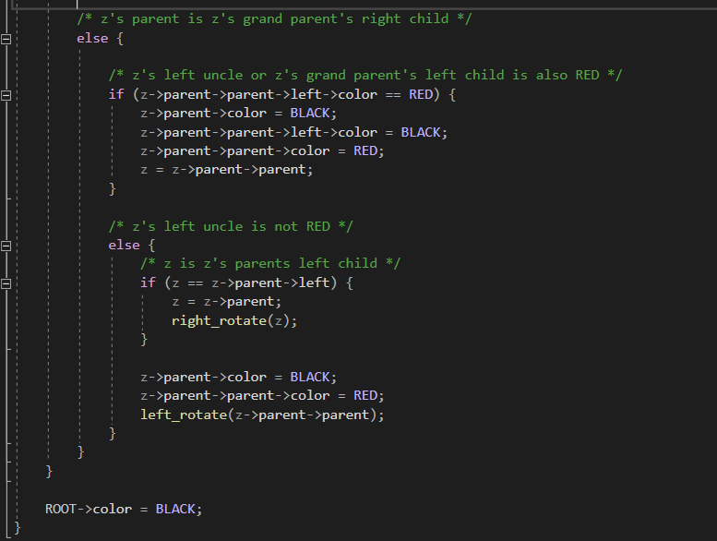
Tree balancing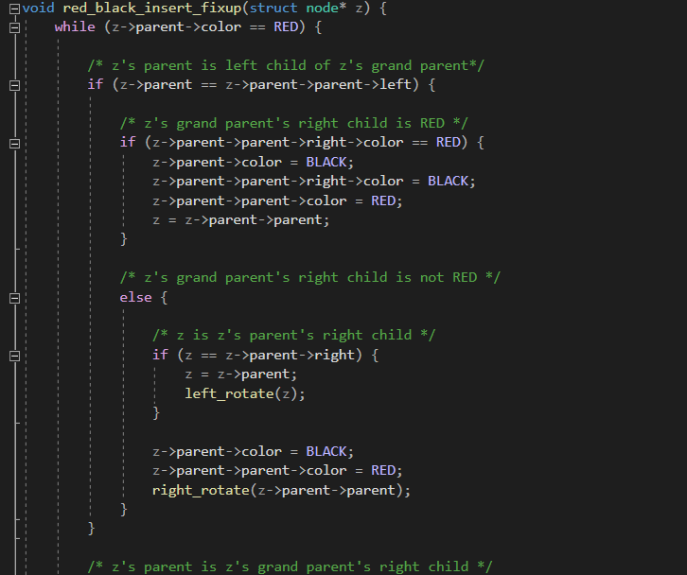
If the parent is red then the function checks whether the color of the inserted node’s uncle is red, if yes the colours it black. If the uncle is black then rotates the parent to the right if it is a left child, and rotates left if its a right child.
At the end always sets the root black.
Search method:
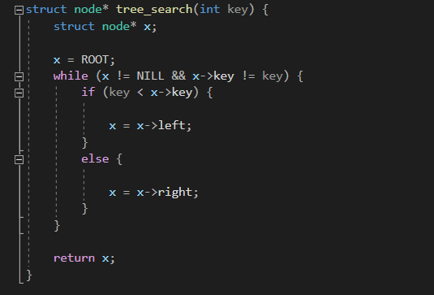
This method compares the seached value and the value of current node. (Starting from root of course) And if the searched value is higher then it continues right, if its lower then to the left.
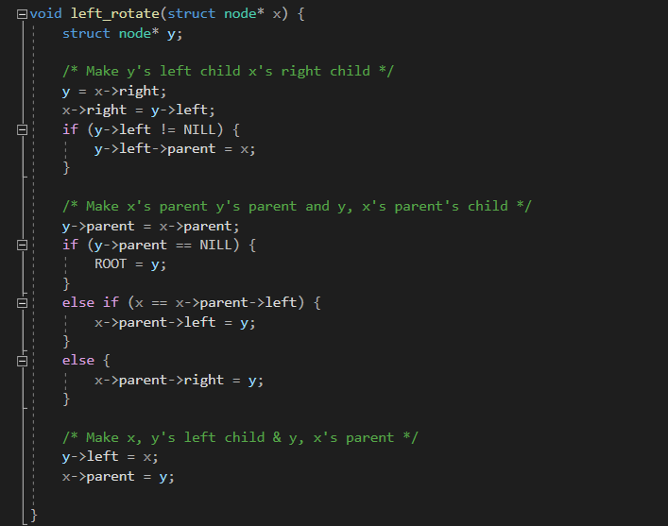
Left rotation
First it makes the y’s left child x’s right child.
Then it makes x’s parent y’s parent and y,x’s parent’s child.
At the end it makes x,y’s left child and y, x’s parent.
Right rotation:
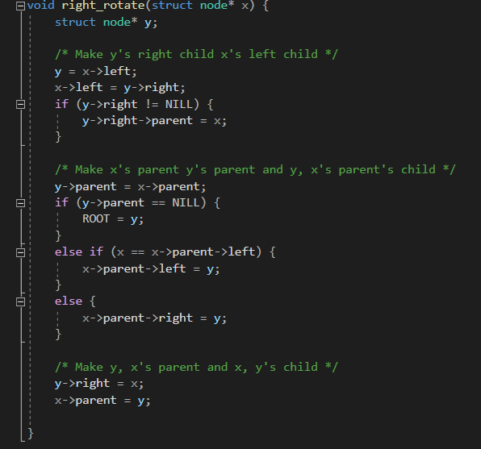
works the same way, but in reverse
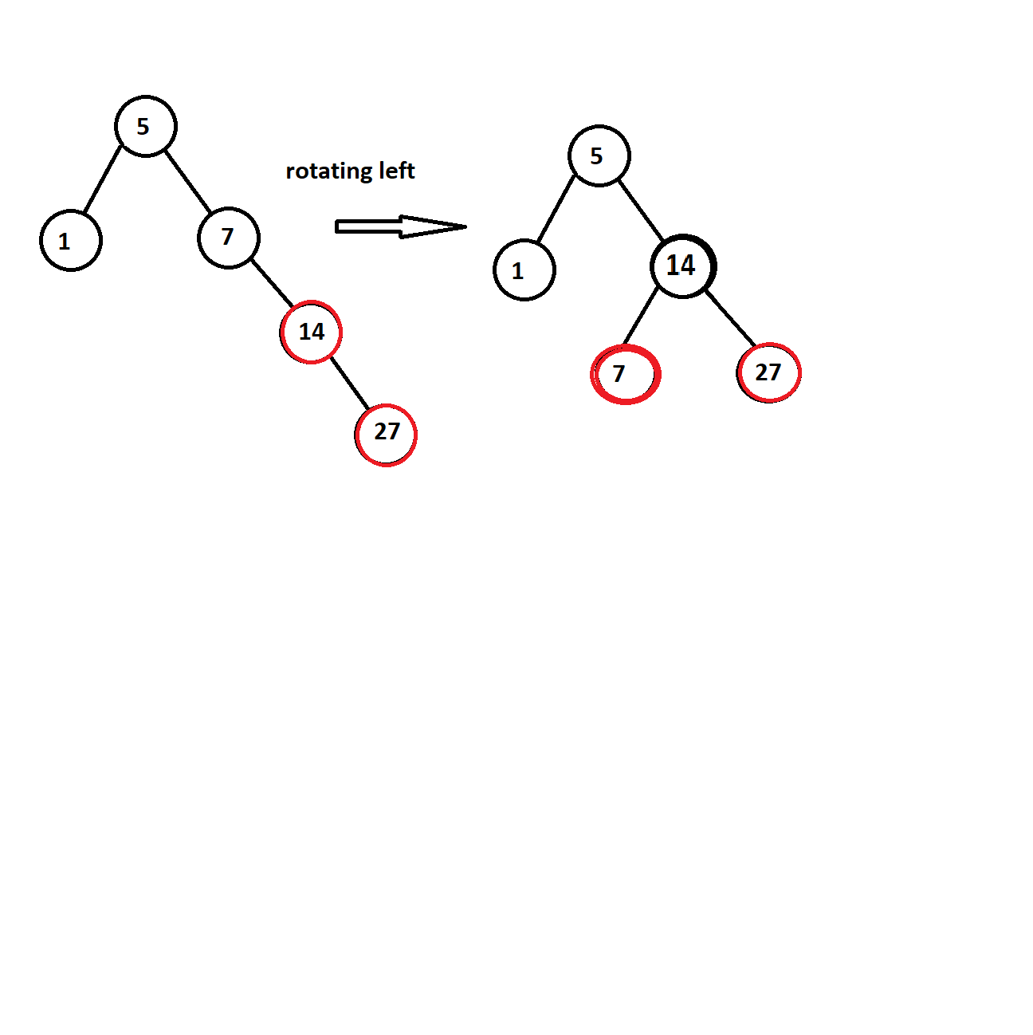
Example of rotation:

Testing Red Black Tree algorithm:
I created 4 different specific tests for checking all the important parts of the algorithm.
(I also did random value tests with large numbers. That can be found in the search,insert efficieny comparison at the end, where I compare the search and insert time of closed hashing and open hashing hast tables, and also the red black tree.)
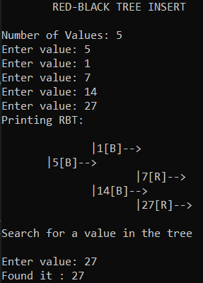
1.Basic test - A simple specific test, where I check insert,search with given values.
Result of the test:
2.Rotation test: (explanation in the comments) Result of the test:
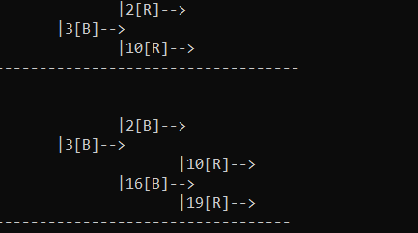
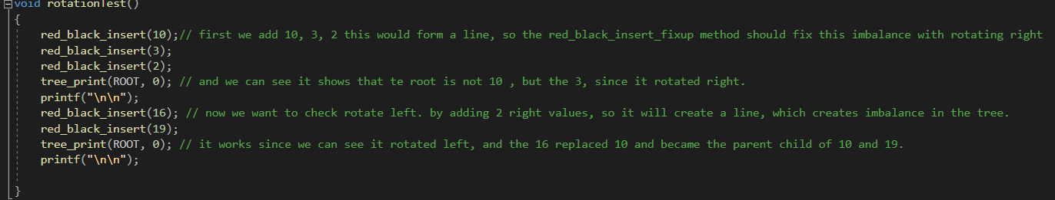
3. Traversal Test:
Here I checked if the inorder and preorder traversals worked. They did, the only difference between the two is that preorder, always starts with 10. Result of the test:
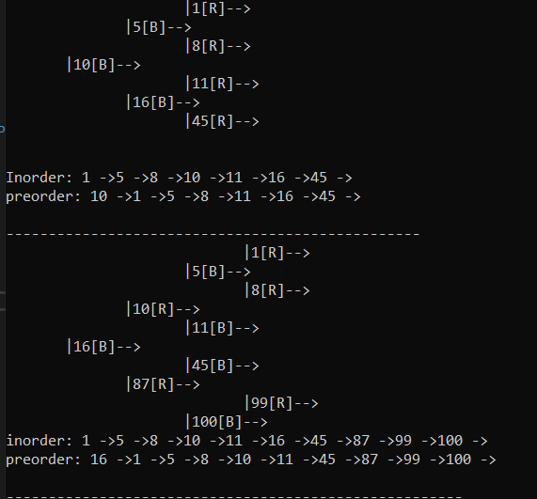
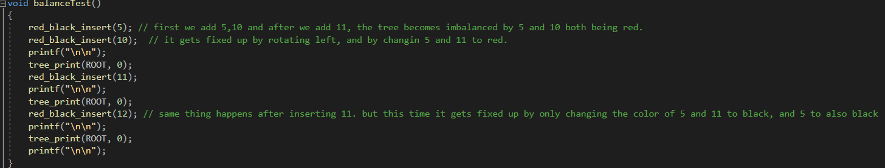
4.Balance test:
Checking if the insert_fixup method works properly, by balancing the tree everytime something is inserted, by either rotating or recoloring nodes.
Explaining in the comments:
Result of the test:
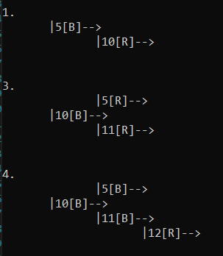

3. Hash table
Source of the implementation: https://www.log2base2.com/algorithms/searching/open-hashing.html

This implementation uses open hashing, which means that values with the same hash key get chained together, using a singly linked list.
Main functions:
void init()
void insert(int value)
int search(int value)
int delete(int value) this one will not be tested.
In this implementation uses the following structure:
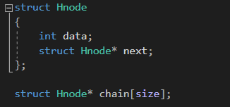
Insert method:
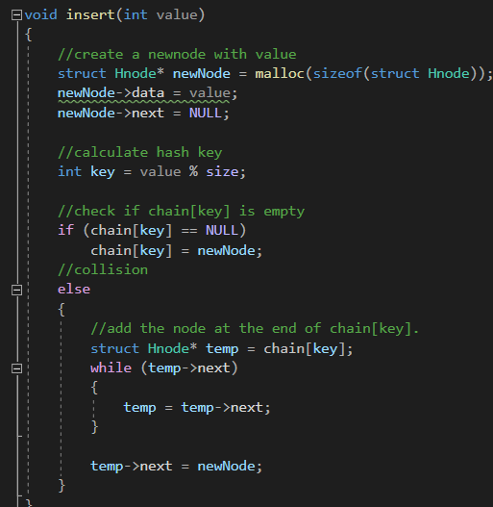
This method adds the data into the array slot with the index that corresponds to the given hash key, if that slot is already occupied then just simply links it to the one that is occuping it.
Search method:
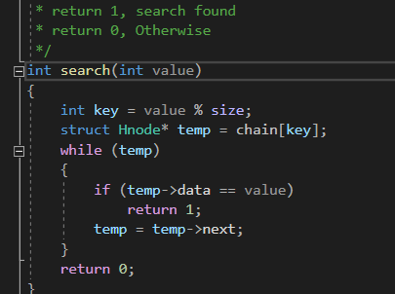
Creates the hash key by getting the modulo of the data, then go finds the corresponding array slot and goes through the singly linked list until he finds/doesn’t find the value.
Returns 1 is has been found, and 0 if not.
Testing open hash table

For testing hash tables I created 2 tests:
1.Basic hash table test - testing the insert,search functionalities.
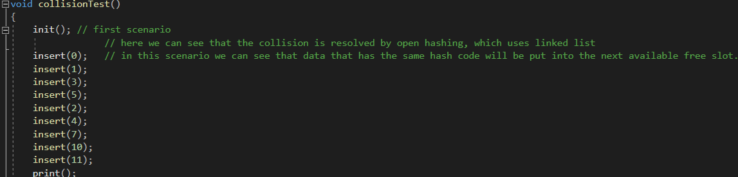
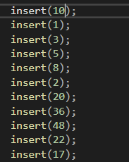 Result of the test: 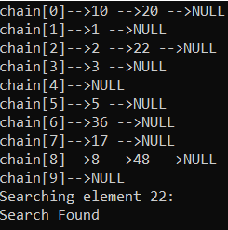
2.Collision test - testing collisions.
Result of the test:
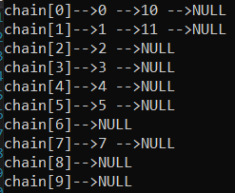
Insert time efficiency comparison between Closed,Open hash table and Red Black Tree
Here I am allocating random numbers and each time different amount:
Test 1 – Inserting 100 amount :
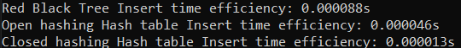
Test 2 - Inserting 1000 amount :
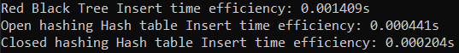
Test 3 - Inserting 10 000 amount:
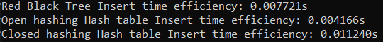
Test 4 – Inserting 100 000 amount:
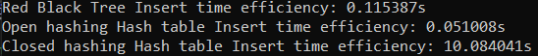
From the results we can conclude when it comes to large amount of number inserts the most efficient data structure is the open hashing hash table.
If it comes to smaller amounts of number inserts then closed hashing hash table is the best.
Meanwhile Red Black Tree is being the least efficient in small amount number inserts, and being the second in large amount of number inserts.

Search time efficiency comparison between Closed,Open hash table and Red Black Tree
Here I am allocating random numbers and each time different amount:
Test 1 – Searching 100 amount :
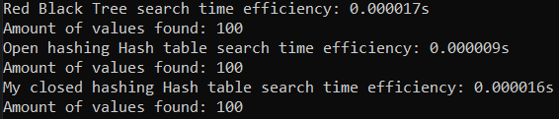
Test 2 - Searching 1000 amount :
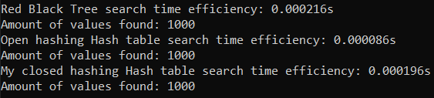
Test 3 - Searching 10 000 amount:
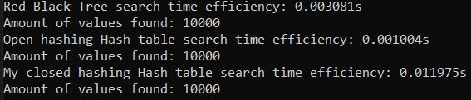
Test 4 – Searching 100 000 amount:
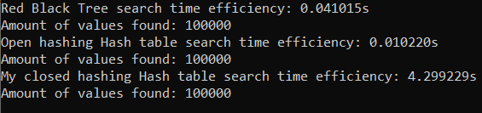
From the results we can conclude when it comes to both large and small amount of number searches the most efficient data structure is the open hashing hash table.
Closed hashing based hash table is only slighty more efficient than Red Black Tree when it comes to small amount of numbers searches
Meanwhile Red Black Tree is being the least efficient in small amount number searches, and being the second in large amount of number searches.

Conclusion

I think my implementation of the closed hashing hashed table could have been far better, since I only used integers to represent data, which made it simple. With structures it could have been done way better.
Closed hashing is known to be inferior to Open hashing when it comes to large amount of data, and superior to it when it comes to small amount of data and my test show this to be true.
One other thing I could have done better is the hash algorithm itself. By not just using modulo, but actually creating a complex algorithm for it. Since the one I implemented is the most simple one and not secure at all.
When it comes to my tests I think I did a good with comparing the time complexity of each data structure. I also tested each important method for the Red Black Tree and for both hash tables.

